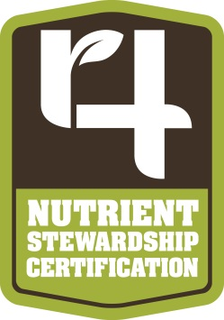

The following wording is a sample of the information that could be used to inform growers about proper nutrient application. This text is also in line with the 4R Nutrient Stewardship Certification Standard.

To help maximize economic benefit of your phosphorus fertilizer investment while reducing phosphorus runoff that contributes to algae blooms in Lake Erie we recommend:
- Phosphorus injection, subsurface banding, or broadcasting with immediate incorporation as preferred placement methods unless the field has been in continuous no-till for at least three years, or application is on a field with surface cover from an existing cover crop or growing crop.

- Phosphorus applications are not made on frozen or snow covered ground.

- Broadcast applications of phosphate without immediate incorporation are not made if the NOAA weather forecast indicates a greater than 50% chance of a rainfall event involving more than an inch of rain will begin within the next 12 hours.

- No fall application of nitrogen fertilizer above 50* pounds for spring planted crops.

- The inclusion of a minimum setback distance (e.g., 35-100 ft.) of applications near sensitive areas, such as tile inlets, well heads, gullies, and water bodies.

*Rate is based on typical rates as applied with fall application of typical phosphate sources; research will be reviewed and conducted to determine if this amount needs to be revised. Records of application will be compared to the recommendations on file. Only applicable to the full-service customers.

